Rocket Motors (Research)
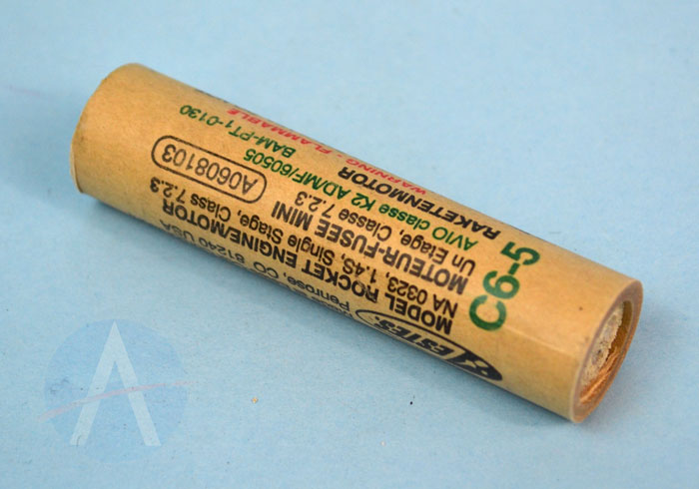
The below diagram is the schematic view of the actual rocket motors. Below is the C6-5/4 ROCKET MOTOR whose working are :-

C6-5 aur C6-4 Rocket Motors Kya Hain?
Ye motors "Estes-style" black powder motors hote hain. Inka code (C6-5) inki taqat aur timing batata hai:

Code ka Matlab: C6-5
- Pehla Letter (C): Total Impulse. Ye motor ki total "energy" batata hai. 'C' category ka matlab hai ki isme $5.01$ se $10.0$ Newton-seconds ki power hai. (A se dugna B, B se dugna C).
- Pehla Number (6): Average Thrust. Ye batata hai ki motor average kitne zor se push karegi. 6 ka matlab hai 6 Newtons ka average dhakka.
- Second Number (5 ya 4): Delay Time. Jab motor jalna band kar deti hai, uske kitne seconds baad parachute khulega.
  - C6-5: 5 seconds ka wait.
  - C6-4: 4 seconds ka wait.

Rocket Motor ke andar kya hota hai? (Internal Components)
Ek commercial motor ke andar ye 5 main cheezein hoti hain:
- Nozzle: Ye mitti (clay) se bana hota hai. Iska kaam exhaust gases ko speed dekar thrust paida karna hai.
- Propellant: Solid black powder ka block jo jalkar rocket ko uper bhejta hai.
- Delay Element: Ye dhire-dhire jalta hai. Isse thrust nahi milta, bas dhua nikalta hai taaki aap rocket ko track kar sakein.
- Ejection Charge: Ek chota sa black powder ka dhamaka jo rocket ke andar pressure banata hai taaki parachute bahar nikal sake.
- Clay Cap: Top par mitti ki packing jo pressure ko uper nikalne se rokti hai.
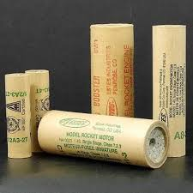
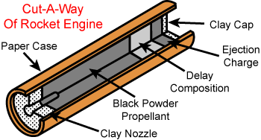

Homemade KNSU Rockets
NSU ka matlab hota hai Potassium Nitrate ($KNO_3$) aur Sucrose (Sugar). Isse "Rocket Candy" bhi kehte hain kyunki isme asli cheeni (sugar) use hoti hai.

Iski Chemistry:
Isme Potassium Nitrate (Oxidizer) aur Cheeni (Fuel) ko milaya jata hai. Inka reaction kuch aisa hota hai:
$$48KNO3 + 5C12H22O11 → 24K2CO3 + 36CO2 + 55H2O + 24N2$$

KNSU Motor ke Parts:
- Casing: Aksar PVC pipe ya hard paper tube ka istemal hota hai.
- Propellant: KNSU ka mixture jo thanda hone par pathar jaisa sakht ho jata hai. Iske beech mein ek "core" (shed) banaya jata hai taaki ye jaldi aur tezi se jale.
- Nozzle: Isse aksar cement ya bentonite clay se banaya jata hai.
- Bulkhead: Uper ka hissa jo puri tarah seal hota hai.

Banane ka Process (Short mein):
- Grinding: Dono chemicals ko barik powder banaya jata hai.
- Heating: Inhe halki aanch par melt kiya jata hai jab tak ye peanut butter jaisa na dikhne lage. (Dhyan rahe: Khuli aag par kabhi nahi!)
- Casting: Garam mixture ko casing ke andar bhara jata hai.
- Curing: Ise thanda hone ke liye choda jata hai jab tak ye solid na ho jaye.
Safety Warning: KNSU bahut khatarnak ho sakta hai. Agar nozzle chota ho ya mixture sahi na ho, toh motor fat sakti hai (ise CATO kehte hain). Hamesha safety glasses pehnein aur dur rehkar test karein.

